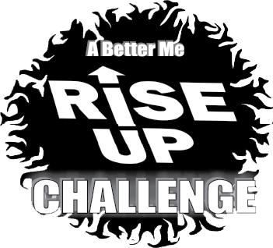 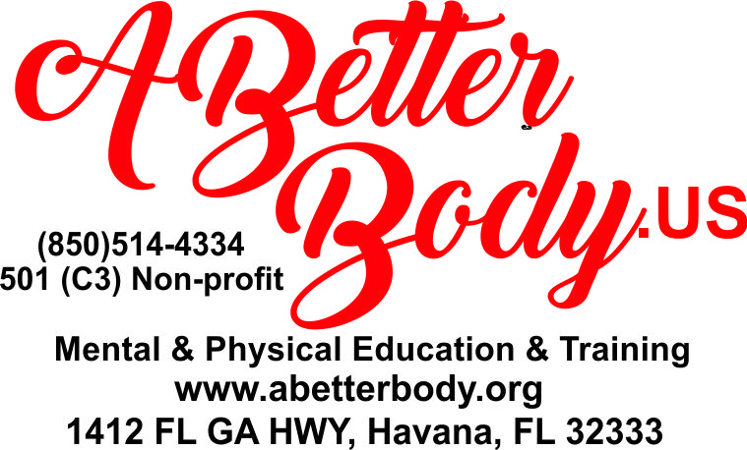

***It’s time to work on our fitness!! We all know the importance of a healthy mind and body.***

***Our team works hard to bring awareness to A Better Body.US programs. I am so grateful for those who have donated in the past. Whether it was by purchasing a shirt, being a sponsor on the back of the shirts for our (bully prevention, fitness challenges, life skills classes or personal safety seminars), all these efforts keep our participants enrolled in the A Better Body Programs. This is for our Gadsden and Leon County communities.***

***The Rise UP Challenge 2 is a 21-day fitness challenge of which participants will keep a chart on the activities listed. All participants will receive a shirt if we get enough sponsors. Children as young as 6 up, adults and seniors. Even those with special challenges can participate. We can modify the activities for them.***

***If you would like to enroll in the challenge, I will send you the waiver and log form to keep track of the activities or be a sponsor, please respond by calling 850/514-4334 OR 850-566-4544 Anne Radke or email*** [***mastertrainer@abetterbody.org***](mailto:mastertrainer@abetterbody.org)***. Mail your payment to: A Better Body 1412 FL GA HWY Havana FL 32333 if you wish to be a sponsor or donate.***

**The Challenge begins May 1st-May 21,2023. Deadline for Sponsors April 7th for both Sponsors and Participants in order to get a free shirt.**

**The ways you can help are listed below and remember it’s a tax write off.**

**Sign up ITs FREE!!!! Email request to mastertrainer@abetterbody.org.**

**Challenge Begins May 1st thru the 21st. Turn in log sheet May 22nd by in person or email or text.**

**Sponsor on back of shirt $50**

**Sponsor Medals for the winners $100**

**Buy a shirt no sponsors on the back $25**

**Or just make a donation $10 or more.**

**After we pay for the shirt and medals, the rest to fund children in the ABB 4Me programs so more can come! We encourage Businesses and Church groups to participate.**